Name: Ryan C. Elico Section: BSIT – 501

1. LOGGING IN

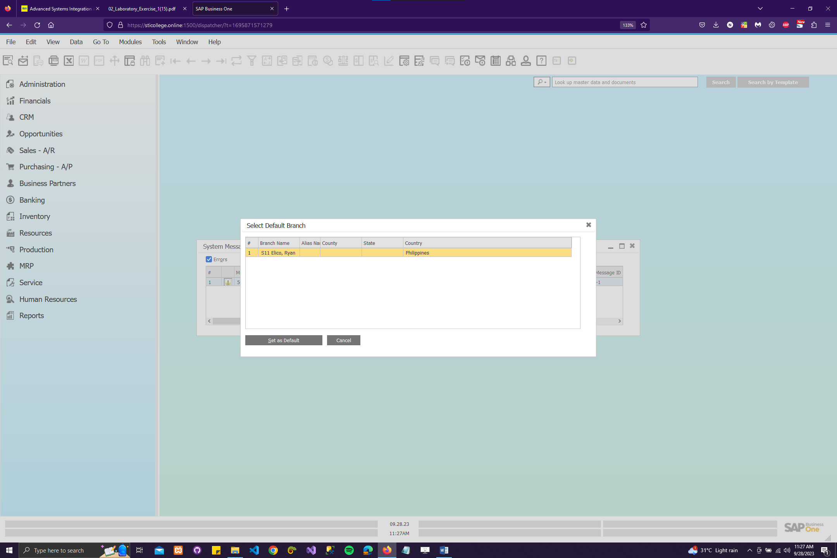

Caption: My workflow begins with the initial step of logging in. I open a web browser and enter the URL provided by my instructor. Next, I select the designated server and company as instructed. To access the system, I input the user ID and password specific to my assigned branch, ensuring that I'm using the correct credentials. It's important to note that each student has a unique branch assignment. Once successfully logged in, I must remember to set my default branch to the one assigned to me for seamless navigation within the SAP B1 environment.

1. CURRENCIES (Section 3 of the Business Blueprint)

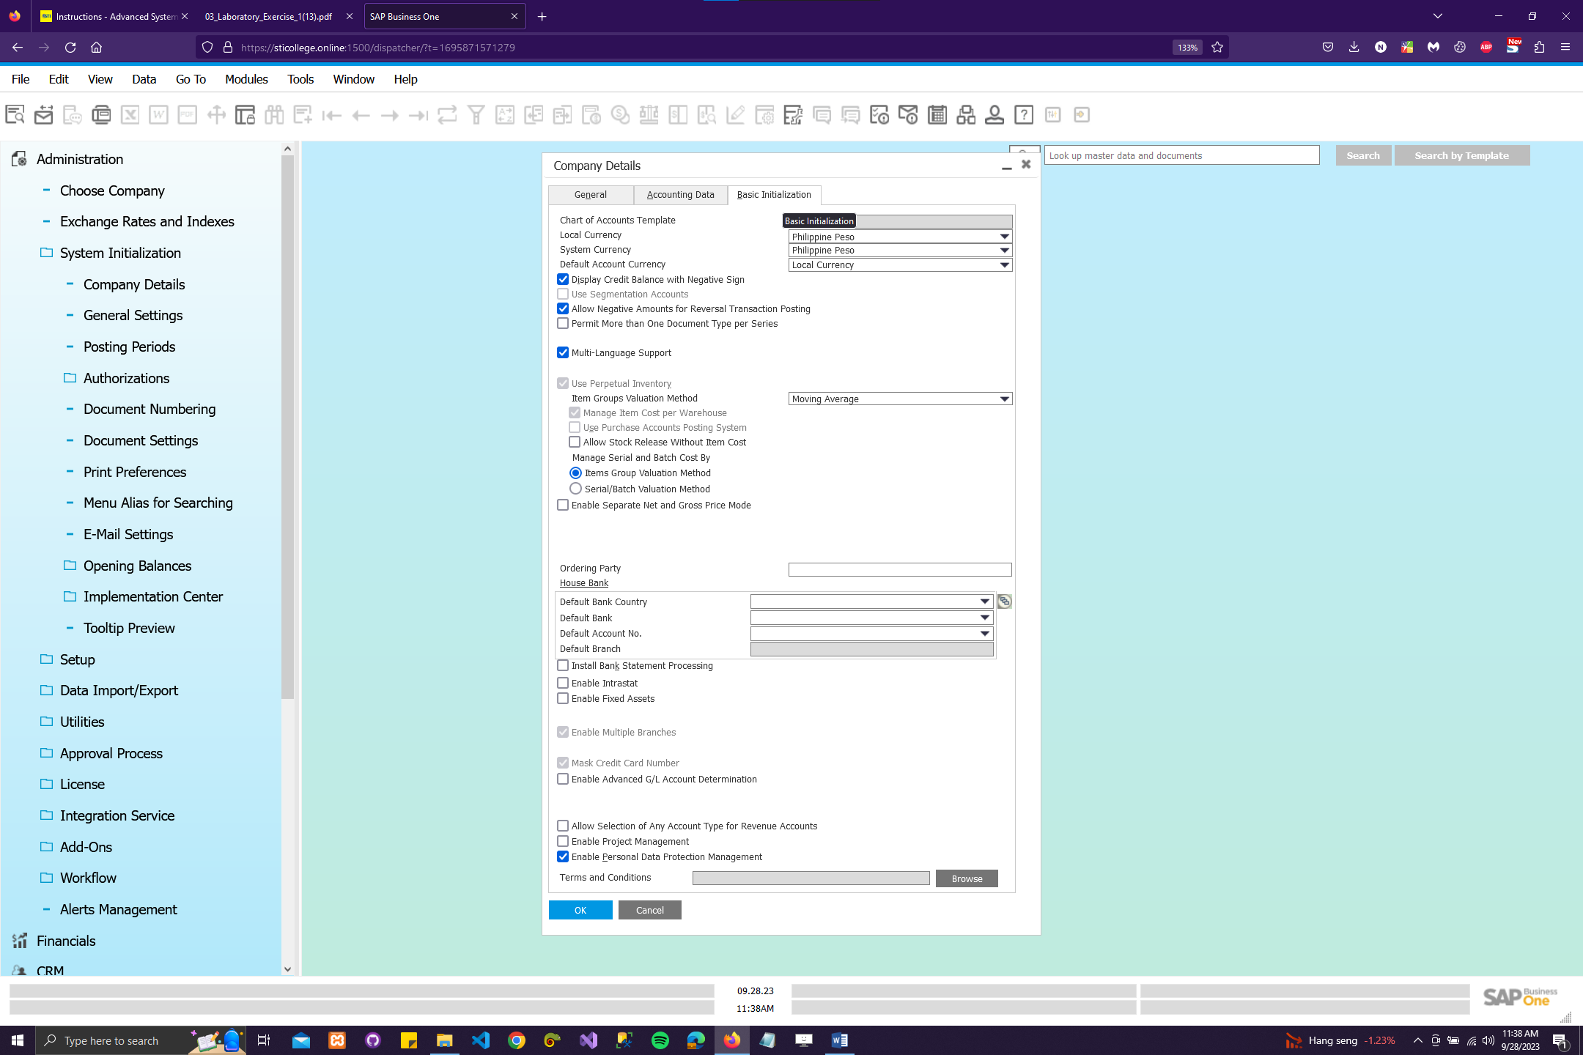

Caption: In SAP Business One, within Section 3 of the Business Blueprint, which pertains to currencies, my first step is to access the Company details where currency settings are managed. Here, I ensure that the required currencies, such as Philippine Peso and USD, are already defined in the list of available currencies. This involves confirming their presence and settings, ensuring that they are properly configured to facilitate financial transactions and reporting within the system, thereby maintaining accurate and efficient currency management for the company.

1. BANK INFORMATION (Section 5 of the Blueprint)

3.a - Add a New Bank

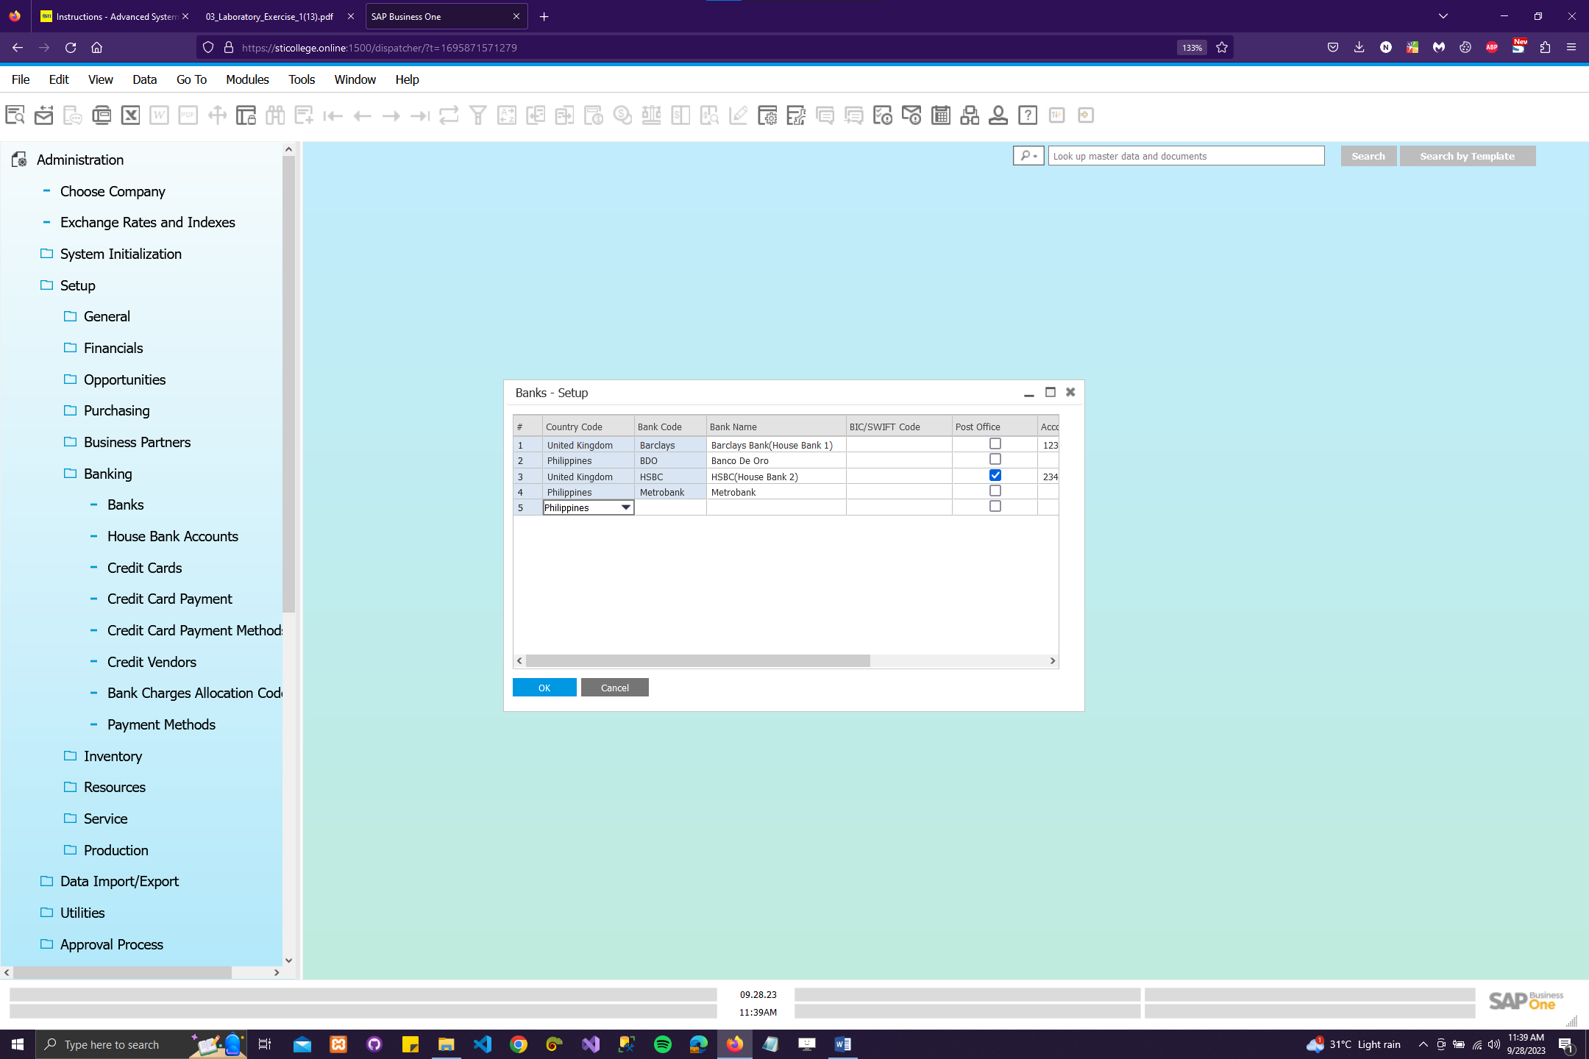

Caption: I follow a series of steps to add a new bank to the system. First, I navigate to the 'Administration' menu and select 'Setup' followed by 'Banking' and then 'Banks.' In the 'Banks - Setup Values' window, I set the 'Country Code' to Philippines and fill in the 'Bank Code' as Metrobank and 'Bank Name' as Metrobank. Next, I choose 'Update' without closing the window. To add another bank, I repeat the process by entering 'BDO' as the 'Bank Code' and 'Banco De Oro' as the 'Bank Name,' with the 'Country Code' still set to Philippines. Afterward, I capture the 'Banks – Setup' window and paste it into my document, labeling it as 'Banks-Setup.' Finally, I choose 'Update' and then click 'OK' to save the changes.

3.b - Set the House Bank

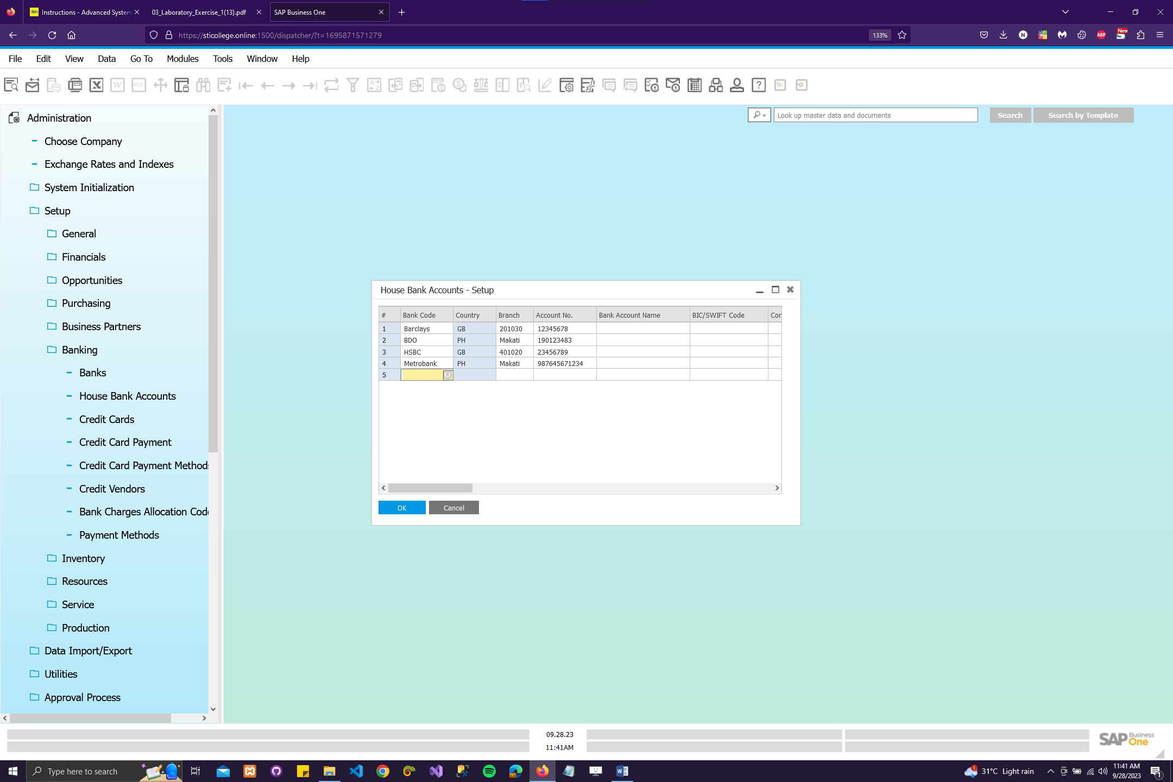

Caption: I start by setting the House Bank Account for Metrobank by navigating to Administration > Setup > House Bank Accounts. In the House Bank Accounts – Setup Values window, I specify the Bank Code as Metrobank, Country as Philippines, Branch as Makati, Account No. as 987645671234, and G/L Account as A1121. Next, I choose the "Update" option, making sure not to close the window yet. Then, I proceed to set up the House Bank Account for BDO, where I enter the Bank Code as BDO, Country as Philippines, Branch as Makati, Account No. as 190123483, and G/L Account as A1122. After this, I capture the House Bank Accounts – Setup window and paste it into my document, labeling it as "House Bank Accounts." Finally, I choose "Update" and confirm with "OK" to complete the process.

1. ITEM GROUPS (Section 9 of the Business Blueprint)

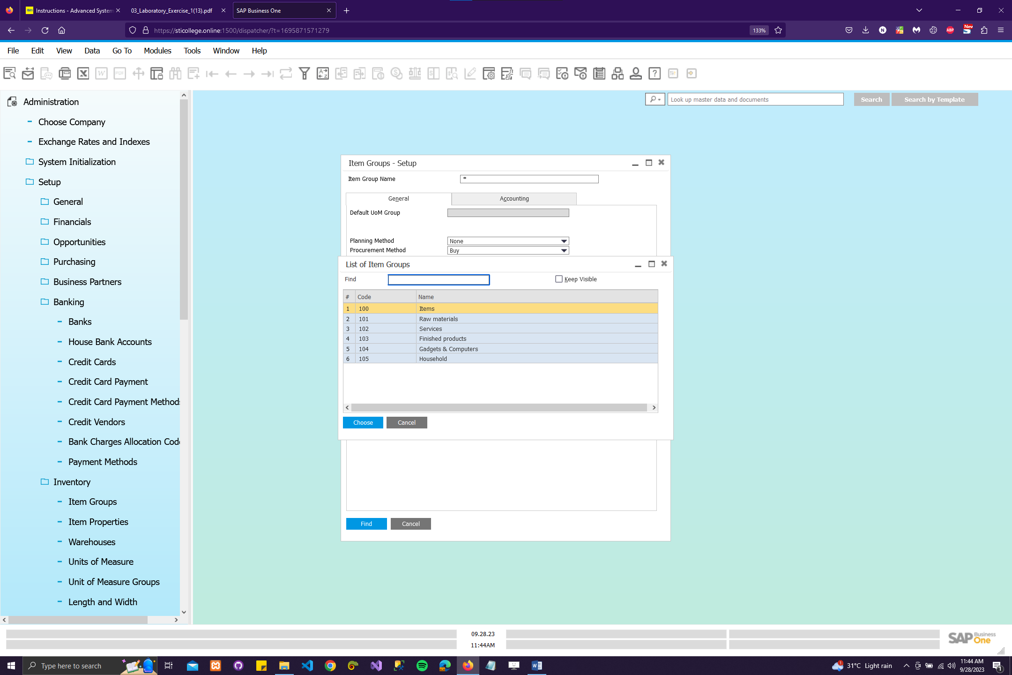

Caption: I follow a specific process in Section 9 of the Business Blueprint. First, I navigate to Administration > Setup > Stock Management > Item Groups. Then, I input the required item groups, including their names (limited to 20 characters), such as "Gadgets & Computers" and "Household." I set default parameters for each group, specifying the Default UoM Group as "Manual," Default Planning Method as "MRP," and Default Procurement Method as "Buy." After ensuring all details are correct, I click "Add" to save the item groups. Finally, I capture the information for the two added groups, paste it into my document, and label it as "Item Groups." This process helps in effectively managing item groups within SAP B1.